Lab No. 9 &10 (2) : - output
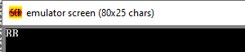

Lab No. 9&10 (3) :- Output
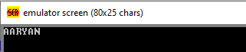

Lab No. 9&10 (4) :- Output
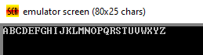

Lab No. 9&10 (5) :- Output :-
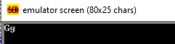
&
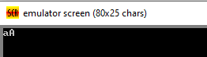
Lab No 9&10 (6) :- Output
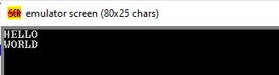’
Lab.No. 9&10 (7) :- Output
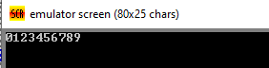

Lab.No. 9&10 (8) :- Output



